Accessibility Statement
At Rockstar Energy Presents TRNSMT Festival we are committed to providing a welcoming and inclusive environment for all our attendees.
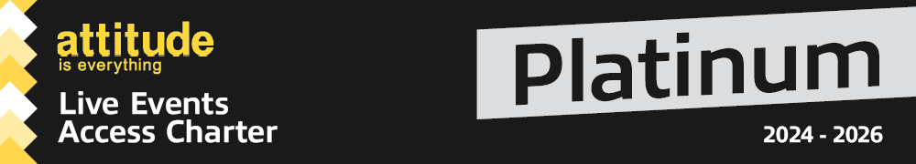
We are extremely proud that Rockstar Energy Presents TRNSMT Festival has been awarded the Platinum level of Attitude is Everything.
The Attitude Is Everything Platinum Award recognises the festival’s commitment to providing the best possible experience and understanding the potential access requirements of Deaf, disabled, neurodivergent people and those with health conditions.
Rockstar Energy Presents TRNSMT Festival has a dedicated accessibility team working all year round to assist customers with accessibility requirements.
Please note that our accessible facilities are unable to cater for people with temporary impairments. This is considered to be anything that affects an individual for less than 12 months such as broken bones, healing injuries or pregnant women.

Please remember to check general event information in addition to the accessible information provided on this page.

Applying for Accessible Facilities
If you wish to apply for any of the accessible facilities at Rockstar Energy presents TRNSMT Festival, please follow the steps below.
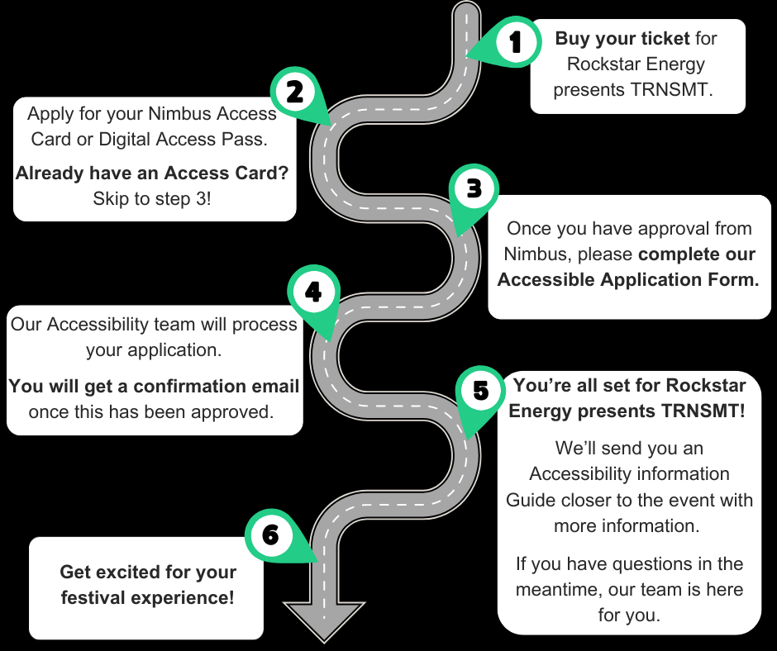

1. Buy your Rockstar Energy presents TRNSMT Festival Ticket
- Buy your standard ticket via Ticketmaster
- Do not purchase a ticket for your essential companion. If your Access Card or Rockstar Energy presents TRNSMT Festival Digital Access Pass indicates the essential companion requirement, we will automatically provide you with an essential companion ticket free of charge. See 'Essential Companion' section below for full details.
After purchasing your ticket, move to Step 2.

2. Check you have a Valid Access Card or Digital Access Pass.
A. Already Have a Valid Access Card or Digital Access Pass?
- If you have valid Access Card or a Digital Access Pass from another Live Nation Festival (view list of participating festivals), skip to Step 3.
B. Don't Have a Valid Pass?
- You'll need to apply for a free Rockstar Energy presents TRNSMT Festival Access Pass via Nimbus Disability.
How to apply:
- Validate your access requirements with Nimbus by providing supporting documentation and information.
- Nimbus will assess your application.
- Once approved, you'll be issued your Digital Access Pass (or an Access Card if you've upgraded).
- Your Pass will be valid for 3 years at Rockstar Energy presents TRNSMT Festival and other Live Nation festivals (view list of participating festivals)

You can apply for a Nimbus Access Card or free Digital Access Pass here.

If you have any questions or concerns regarding your application to Nimbus. Please do contact our accessibility team who are here to support!

3. Complete our Rockstar Energy presents TRNSMT Festival Accessible Facilities Form.
Once you've received confirmation of your Digital Access Pass (or Access Card) from Nimbus, you can apply for accessible facilities via our Rockstar Energy Presents TRNSMT Festival facilities form.
You can CLICK HERE to apply for our accessible facilities.
Please note you must have your Nimbus Card or Digital Access Pass ID number ready - as you will need to input this on your application.

Please note:
- Spaces for the accessible viewing platform and viewing area are allocated on a first-come, first-served basis (based on your application date) and may reach full capacity.
- While we will do our best to accommodate everyone, if the platform is full, we will contact you to discuss alternative facilities.
- If no suitable alternatives are available, a refund will be issued.
- Important: You must have a confirmed Digital Nimbus Pass before applying or let us know your application for this is in progress at point of submission.
- Make sure you receive an acknowledgement email when submitting the form. If you do not get this, your form has not been submitted correctly.
4 – Our Accessibility Team will review your Application
You will receive email confirmation of your approved facilities. If you have any questions, our Accessibility Team is here to support you.

5 – Receive your Accessibility Guide and Arrival Information
- This will be emailed to you closer to the event date and include further information on the accessible facilities on site.
- Please contact us if you have any questions in the meantime.

6 – Enjoy the Festival!
We look forward to welcoming you to Rockstar Energy Presents TRNSMT Festival

Essential Companion Ticket
An essential companion ticket is provided to those customers who would be unable to attend without the help and support of another person.
Requirements:
- If your Access Card or Rockstar Energy Presents TRNSMT Festival Digital Access Pass indicates the essential companion requirement, we will automatically provide you with an essential companion ticket free of charge.
- Your essential companion must be willing and able to perform all your requirements and must provide assistance to you during the unlikely event of an evacuation or other emergency.
- If you need different people to assume the role of your essential companion throughout the festival, please indicate this on the Rockstar Energy Presents TRNSMT Festival Accessible Facilities Application form in the Additional Information section.

Accessible Facilities
Accessible Toilets
Accessible toilets are available at the accessible viewing platform/area and the main toilet blocks within the arena.
An accessible changing facility will be available in the accessible area. The unit includes a toilet with retractable grab rails on either side, an electric hoist, and an adjustable high changing table.
For VIP ticket holders, a luxury accessible trailer is also available in the VIP Garden.

Raised Accessible Platform
The Accessible Viewing Platform is a raised platform offering a prime view of the stage, and includes:
- Ramped access
- Charging points for mobility scooters and electric wheelchairs
- Accessible toilets located nearby
- Foldable Plastic Chairs
- An Accessibility team on hand to assist
Companions are welcome and will be seated alongside the ticket holder.
Your accessibility wristband will give you access if you have been approved for this facility.
Please note: The Raised Accessible Platform has limited capacity and is reserved for approved accessibility customers plus essential companion(s) only.
Spaces for the accessible viewing platform are allocated on a first-come, first-served basis (based on your application date) and may reach full capacity. While we will do our best to accommodate everyone, if the platform is full, we will contact you to discuss alternative facilities. If no suitable alternatives are available, a refund will be issued.

Ground Level Viewing area
The Ground Level Viewing Area is designed for individuals who prefer a less crowded space and the option to sit for short periods.
This area is primarily for standing, with limited seating available for short breaks. Please note that while seated, your view may be partially blocked by standing fans in front of you.
Spaces for the accessible ground level viewing area are allocated on a first-come, first-served basis (based on your application date) and may reach full capacity. While we will do our best to accommodate everyone, if the viewing area is full, we will contact you to discuss alternative facilities. If no suitable alternatives are available, a refund will be issued.

Accessible Bar, Food and Merchandise Lanes
Lowered counter bars and accessible lanes will be available at most bar areas across the venue for all accessible ticket holders.
Where a lowered counter isn’t available, a staff member will be happy to assist by coming around the bar to take your order and provide any support you may need.
All food and merchandise stalls will have an accessible queue-jump system in place, clearly signposted at each location. Staff will be fully briefed to recognise and assist guests wearing accessible wristbands.
A dedicated bar (limited menu) is available at the main stage accessible viewing area.

Accessible Travel
Car park
Rockstar Energy Presents TRNSMT Festival accessible car parking is located at the East side of the festival on The Grn. Post code is: G40 1EF
Accessible parking must be pre-booked using our Accessible Application Form. Parking without prior approval will not be permitted.
- If you require both accessible parking and other accessible facilities:
Please follow the full application process outlined in the ‘Applying for Accessible Facilities’ section. Once you have your digital access pass (or a Nimbus Card, if you already have one), you can complete the Accessible Facilities Form and include accessible parking in your application. If parking spaces are available, your request will be approved.
- If you only require accessible parking:
You may skip directly to Step 3 and submit the Accessible Facilities Form, ensuring that you select accessible parking in your request. Our Accessibility Team will then contact you to request a copy of your Blue Badge. If parking spaces are available, your request will be approved.
Please note that at the end of the show car will be held from leaving The Grn until it is safe to do so.
The accessible car park to the accessible entrance is estimated 250 meters.
Please note cars are not permitted to stay overnight.
Motorhomes are not permitted.

Accessible Pick up and Drop off
Accessible Pick up and Drop off will be available near the accessible entrance. More details about this will be shared closer to the event.
Please note there will be a point where we will not be able to send vehicles through road closures due to the pedestrian footfall.

Public Transport
Please refer to the Getting There section for information on available public transport links (buses, trains and the subway).

Site Description
Weather
This is an outdoor concert, and we advise attendees to dress appropriately and bring suitable clothing for changing weather conditions. As temperatures may drop in the evening, we recommend bringing a jacket or additional layers for warmth and comfort.

Ground Conditions
Rockstar Energy Presents TRNSMT Festival takes place on Glasgow Green, a greenfield site. Therefore it is relatively flat but does have uneven terrain in parts.
The arena features grass, gravel, limited hard-standing paths and temporary trackway.
You can view Glasgow Green on Google Maps here: Glasgow Green
Please note: Poor weather conditions can impact the terrain, potentially making some areas inaccessible for wheelchair users or customers with mobility challenges.

Route from accessible parking – There is a hard-standing path through a lightly wooded area of the park from the parking area to the accessible entrance. This is mostly level apart from the kerb to the pavement.
Route from City Centre OR Bridgeton Station – This route is made up of pavements and roads through city streets. There are pedestrian crossings with dropped kerbs throughout this route.
The Stages
Main Stage – The area around this stage is mostly flat ground consisting of grass, temporary trackway, and hard-standing paths. There is a raised platform and ground level viewing area at this stage. Main Stage Accessible area – The accessible area includes ground level viewing area as well as a raised structure for the viewing platform, specifically for accessible ticket holders, as well as accessible toilets (including a changing facility), all located within a designated compound.

King Tut’s Stage – The area around this stage is mostly flat grass. There is a hard-standing path along the left side of the stage. There is a smaller raised platform and ground level viewing area at this stage.

BBC Introducing Stage – This stage is positioned at the bottom of a grassy slope. There is a hard-standing path at the top of this slope with views of the stage. There are limited picnic benches on the slope. There is a small ground level viewing area at this stage which is accessed from the side via a hard standing path.

BBC Radio 1 Dance Stage – This area mainly consists of grass. There are hard-standing paths along the sides. These paths have views of the stage but are not in the main area.

Distances
Accessible parking to Accessible entrance: 250 meters approx.
Box office to Accessible entrance: 25 meters approx.
Accessible entrance to Accessible Viewing Platform and Area: 250 meters approx.
Accessible toilet/changing facility to Accessible Viewing Platform: 10 meters approx.
Nearest Bar to the Accessible Viewing Platform: 10 meters approx.
Accessible parking to VIP accessible entrance: 150 meters approx.

D/deaf or Hard of Hearing Facilities

Rockstar Energy presents TRNSMT BSL Information
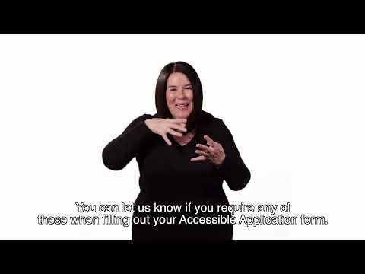

BSL (British Sign Language) and/or Live Captioning
A British Sign Language interpreting service and/or Live Captioning will be provided on request by fully qualified interpreters from Performance Interpreting/Captioners.
Please make sure you request this service on the Accessible Application Form. See the ‘Applying for Accessible Facilities’ tab for more info.
Customers who have requested this service will be contacted by the relevant team for an understanding of which performances they would like covered; this is not guaranteed and subject to change.
Full interpreting schedules will be included in our Accessibility Guide. Details and locations of our information and welfare services available for D/deaf customers will also be available in the Accessibility Guide.
At least 60-days’ notice is advised to ensure we can source and ensure the availability of the interpreters/captioners

Hearing loops
Hearing loops will be available at various locations throughout the event.
Exact locations will be detailed in the Accessibility Pack, which will be sent to all customers prior to the event.

Blind and Low Vision Facilities

Assistance dogs
We welcome assistance dogs to TRNSMT Festival, provided they have been specifically trained to support you, use the designated toilet/spending area, and behave appropriately around other customers.
If you are bringing an assistance dog, please email us in advance so we can prepare a suitable spending area and any other required facilities. You may also indicate this in the accessible facilities form if you are applying to use accessible facilities on site.
Audio Description
Audio Description will be provided on request by fully qualified Audio Describers.
Please make sure you request this in your Accessible Application Form so our team can review your request. For more details, visit the ‘Applying for Accessible Facilities’ tab.
Customers who have requested this service will be contacted by the relevant team to discuss further; this is not guaranteed and is subject to change.
At least 60-days’ notice is advised to ensure we can source and ensure the availability of the audio describers.
Large Print Menus
Large print menus are available at all bars, merchandise stalls, and trader locations throughout the venue.

Sensory facilities
Strobe Lighting and Special Effects
Smoke machines, strobe lights, fireworks and other effects may be in use at this event. Anyone affected by these should bear this in mind and contact our team for support.
If you require further information for a specific performance, please contact us.
Sensory Facilities
Sensory Packs
Sensory packs are available to borrow free of charge from the accessible area. Each pack includes a fidget toy, ear defenders and a sensory distraction item. Packs are provided on a first-come, first-served basis.
You're welcome to bring your own sensory supports if you prefer.
Please return borrowed packs after the show. All items are sterilised between uses, and sterilising wipes are included in the pack if you'd like to clean them yourself.
If you need further sensory provisions, please include this in your Accessible Application Form so our team can review your request. For more details, visit the ‘Applying for Accessible Facilities’ tab.
Sensory Tent
Our Sensory Tent is a dedicated space designed to provide a calm and soothing environment for individuals who may feel overwhelmed by the sensory stimulation at festivals. It offers a retreat for those needing a break from loud noises, bright lights, and large crowds and staff are at hand to assist in this area.

Assistance Dogs
We welcome assistance dogs to TRNSMT Festival, provided they have been specifically trained to support you, use the designated toilet/spending area, and behave appropriately around other customers.
If you are bringing an assistance dog, please email us in advance so we can prepare a suitable spending area and any other required facilities. You may also indicate this in the accessible facilities form if you are applying to use accessible facilities on site.

Welfare Team

There are medical and welfare facilities available. Please ask a member of security to direct you to the facilities if required.
Further information will be released closer to the event.

Accessibility Team, Stewards and Security

An Accessibility Manager and Accessibility Co-ordinator will be on-site, trained in supporting disabled, Deaf, and/or neurodivergent customers. They will oversee the accessibility of the festival and be available to assist with any queries you may have on the night.
All security and stewards based at accessibility points will be briefed fully on procedures in order to provide adequate support and information for accessibility customers.

VIP Garden Accessible Facilities

Please note:
There is no view of the stage from the VIP garden.
There is some seating available on a first come, first served basis.
Ground Conditions
The ground conditions are the same as the festival arena. The site is green field therefore is relatively flat but does have uneven terrain in parts. The ground may be muddy or dusty dependant on the weather conditions. If you require further information please contact us here
Luxury Accessible Toilet
There is a luxury accessible trailer available in the VIP Garden.

If you have any further queries on the accessibility within the VIP area,please contact us here.

Policies/Prohibited Items

Bag Policy
Bags larger than an A4 sheet of paper are not permitted.
If you need to bring a larger bag for medical or accessibility reasons, please let us know by filling out our Accessible Facilities Form and ticking the appropriate box.

Food and Drink
There will be various food options available at the festival.
If you need to bring your own food or non-alcoholic drinks due to a medical condition or your access requirements, , please let us know by filling out our Accessible Facilities Form and ticking the appropriate box.

Medication
You may bring medication in its original packaging with the prescription label clearly visible, or if it is easily recognisable, without requiring prior approval.
If your medication is not easily recognisable, , please let us know by filling out our Accessible Facilities Form and ticking the appropriate box.
Only bring the necessary amount for the duration of the event.
- Keep your medication safe with you at all times.
- Be prepared for screening at entry points, and have any supporting documents ready, such as a doctor’s note, prescription, or correspondence with the accessibility team.

Alternative Formats
Should you require this information in an alternative format (Easy read, BSL translated, Audio or anything further), please contact our team, who will be happy to assist.

Contact Us
We want our fans to enjoy their visit. We appreciate that this may not cover everything you need or wish to know about the event. If you have any questions, please don’t hesitate to contact our Accessibility Team through any of the following channels.

You can fill out our Contact Form here.

Email: access@TRNSMTfest.com.
Post: 272 St Vincent Street, Glasgow, G2 5RL
Phone: 0141 674 9444
Office opening times: 10am – 6pm, Monday to Friday.
Please note we aim to respond to all email enquiries within five working days, however this may take longer during busy times.
On show days access@TRNSMTfest.com won’t be monitored as we’ll be working operationally on-site. Once you arrive at the event please approach a steward, supervisor, or a member of the Accessibility Team for assistance and they’ll do their best to assist.

